**Taurine and calcium carbonate (Caco3) in gentamycin induced nephrotoxicity in albino rats**

Abeer A. Shomana, Mona Al-awama, Usama F. Ahmedb ,Eslam S. Metwallyc* and taghreed A. Samea d

a Department of physiology, Faculty of medicine, Benha University, b department of Anatomy, Faculty of medicine, Benha University, c department of Forensic and toxicology, Faculty of medicine, Benha University and d department of Pathology, Faculty of medicine, Benha University

***Abstract***

Gentamycin is antibiotic used against Gram –ve bacteria. It has nephrotoxic effect due to production of reactive oxygen species (ROS). The aim of this study is to determine the protective effect of Taurine and calcium carbonate in combination with gentamycin. This study was conducted on 24 animals which were classified into 4 groups, control (C group), Gentamycin treated group (G-group) which was injected by 80mg/kg/day intraperitoneal. Gentamycin and taurine treated group (G+T group) which received gentamycin as the pervious group and taurine in a dose of 7.5mg\kg\day. Calcium carbonate treated group (G+ Ca group) received caco3 in a dose of1 g/kg orally in combination with gentamycin in the same used dose. By the end of study biochemical analysis of BUN, creatinine, sodium and potassium were measured. Histopathological examination of the renal tissue was done to demonstrate necrosis of renal tissue. The results cleared nephrotoxic effect of gentamycin as BUN, creatinine and area of necrosis were increased significantly (p<0.05). The effect of both taurine and caco3 was demonstrated but the protective effect of caco3 is more than taurine.

***Key words:*** Gentamycin, taurine, caco3

***Introduction***

Gentamycin an aminoglycoside antibiotic used for treatment of severe threatening infections caused by Gram -ve and gram +ve bacteria. One serious limitation to its use is that, it can cause ototoxicity and nephrotoxicity **(1)**. It has been estimated that up to 30% of patients treated with gentamycin for more than 7 days show some signs of renal impairment **(2)**. The mechanisms involved in gentamycin induced nephrotoxicity remains unclear but different theories are suspected. It has been shown that GM exerts its adverse renal effect by generation of ROS, which results in sever tissue Damage **(3)**. ROS directly act on cell components, including lipids, proteins, and DNA, destroying their structure and cause Peroxidation of membrane lipids **(4).** That is supported by increased MDA levels, one of the products of lipid peroxidation. **(5, 6)**

Gentamicin induces lysosomal phospholipidosis. Inhibition of lysosomal phospholipases, subsequent accumulation of phospholipids, and the formation of lysosomal myeloid bodies have been implicated as direct mechanisms of nephrotoxicity **(7)**. Furthermore, acute tubular necrosis, glomerular damage and renal inflammation are the major events implicated in gentamicin nephrotoxicity **(8)**. The antioxidants effect in either preventing or mitigating gentamycin induced nephrotoxicity has detected **(9)**. The role of renal mitochondria on protection against GM nephrotoxicity has detected. **(10)**

Taurine is the major intracellular free β-amino acid present in most mammalian tissues. It is present naturally in food, especially in seafood and meat. It plays various important physiological roles including osmoregulation, bile acid conjugation, and modulation of CNS function and cell proliferation. (11).The beneficial effects of taurine as an antioxidant in biological systems have been attributed to its ability to stabilize bio-membranes, scavenge ROS to form taurine chloramine (12). Taurine chloramine has been shown to serve as an oxidant reservoir, exhibiting delayed oxidant effects or acting at a distant site (13).This phenomenon is particularly significant in phagocytes, which are a source of taurine-related antioxidants and are prevalent in an early phase of inflammation in the glomerulus and tubules (14).

Since gentamycin induces nephrotoxicity by plasma and subcellular membrane damage which appear to be critical pathogenic events. This might involve competitive displacement of Ca2+ from anionic phospholipids at the plasma and organelle membrane level, decrease in Na–K–ATPase, adenyl cyclase, mitochondrial function and ATP production, protein synthesis, solute reabsorption, and overall cellular function (15).The effect of Ca2+ on gentamicin nephrotoxicity may relate to its ability to inhibit critical gentamicin-renal membrane interactions.

*Aim of the work*

The present work aims to compare the protective effect of taurine and calcium carbonate on renal nephropathy in albino rats.

***Materials and methods***

This experiment was carried out on 24 male albino rats weighted 150–200 g, the rats obtained from Zagazig Faculty of Medicine and handled in accordance with the guideline principles in the use of animals. They were kept under the same condition and had free access to food and water all over the period of the work. The animals were randomly classified into 4 groups (each = 6 rats) and the treatment maintained for 8 days as follow:

* Control group (C- Group): injected with normal saline 1 mL/day/ i.p.
* Gentamycin group (G-group): injected with gentamycin in a dose of 80mg/kg/i.p/day. **(16)**
* Taurine - treated group (G+T group): injected with and taurine (10% aqueous solution) in a dose of 7.5 ml/kg/i.p/day in combination with the same dose of gentamycin applied as in the G-group. **(17)**
* Calcium - treated group (G+Ca group): treated with calcium carbonate (CaCO3) at a dose of 1 g/kg/orally, **(1)** concomitantly with the same dose of gentamycin applied as in the G-group.

The injections were carried out between 9.00 and 9.30 a.m. to minimize the circadian variation in gentamicin induced nephrotoxicity. **(18)**

***Biochemical analysis***

By the end of study, animals were anesthetized by diethyl ether, blood samples (3ml) were collected from the right ventricle, allowed to clot at room temperature, centrifuged at 3000 rotation/ minute. The sera were separated and stored at –20ºC in dark containers for measurement of BUN, serum creatinine, sodium and potassium levels.

***Histo-pathological changes of the kidney tissues:***

Bilateral peri-lumbar vertical incisions were made and Kidneys were dissected, fixed in 10% formalin and then embedded in paraffin wax for light microscopy, then dehydrated through an ascending graded series of alcohol and embedded in paraffin wax. Tissue samples were cut and stained with hematoxylin and eosin (HE). These samples were analyzed using Olympus soft imaging system (analysis life science program).

***Statistical Analysis***

The results were expressed as mean values ± SE for biochemical parameters. Statistical significance between groups was evaluated using independent t test (SPSS statistics. The difference was considered significant at Pb0.05, and high significant at P<0.01 or P<0.001.

***Results***

1. ***Biochemical analysis:***

Table (1): Serum level of BUN, serum creatinine, sodium and potassium level in Group C, group G, group G+ T and group G+ Ca. The results were expressed as mean ± SD.

|  |  |  |  |  |
| --- | --- | --- | --- | --- |
|  | **C- group** | **G- group** | **G+T- group** | **G+Ca- group** |
| BUN (mg\dl) | 12.900±.1.658 | 34.300±2.915* | 20.996±3.055*# | 9.183±14.01# |
| Creatinine  (mg\dl) | 0.348±0.199 | 2.000±0.253* | 1.023±0.150*# | 0.360±0.145# |
| Sodium  (mmol\L) | 160.78±6.104 | 138.03±8.961* | 159.981±13.08# | 151.29±11.08# |
| Potassium  (mmol\L) | 4.366±0.844 | 4.040±0.411 | 4.706±1.124 | 5.186±0.670# |

* versus C-group #versus G- group

Regarding BUN and serum creatinine, It is clearly that both BUN and serum creatinine are highly significant increased in G and G+T groups than C-group as p<0.0001 in both. Both G+T and G+Cagroups show significant decreased level of BUN and serum creatinine than G- group p<0.001. Serum sodium level is significantly decreased in G group when compared with C- group (P<0.001), while in both G+T and G+Cait is significantly more than G-group as p<0.01 and p<0.05 respectively.

Regarding potassium level, it is increased significantly in group G+Ca+2 comparing with G-group (p<0.005).

**Histo-pathological results:**

Table (2): This table shows Necrotic areas detected in renal tissue by histopathological examination in all treated groups, these data is expressed as mean ±S.D.

|  |  |  |  |  |
| --- | --- | --- | --- | --- |
|  | **C- group** | **G- group** | **G+T- group** | **G+Ca– group** |
| **Necrotic area (um)** | 337.9±144.6 | 136221.56±115928.08* | 65515.75±32791.750* | 1903.9±2287.5# |

*versus C-group # versus G-group

Histopathological examination of renal tissue of all tested groups shows increased area of necrosis in G-group than C-group as p<0.01. Also, area of necrosis is increased in G+T group when compared with C group as p<0.001. Comparing with G-group, area of necrosis is highly significant decreased in G+Cagroup is as p<0.01.

**Graph (1): BUN, serum creatinine in C, G, G+T and G+Cagroups**

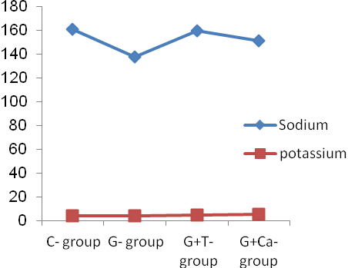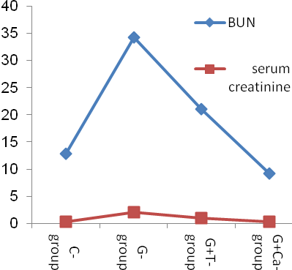

Figure (2): Serum sodium and potassium levels in C, G, G+T and G+Ca+2 groups

**Graph (2): Serum sodium and potassium in C, G, G+T and G+Ca+2 groups**

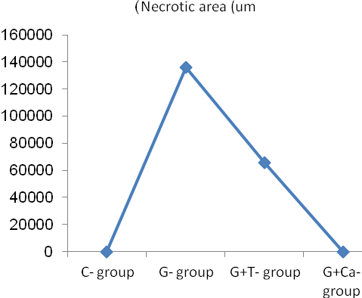

**Graph (3): Necrotic area in renal tissue is detected by histopathological examination**

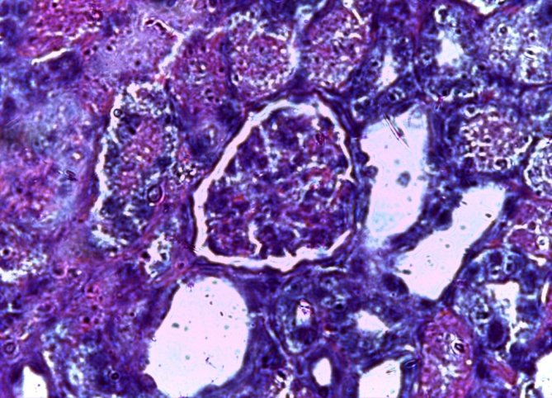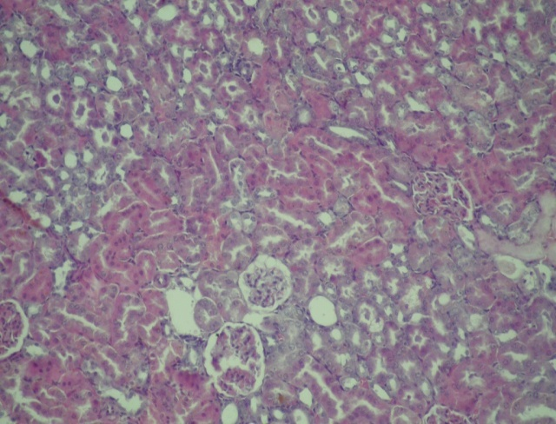

Figure (1-b): Control group (C-Group), show normal renal tissue (HEX600)

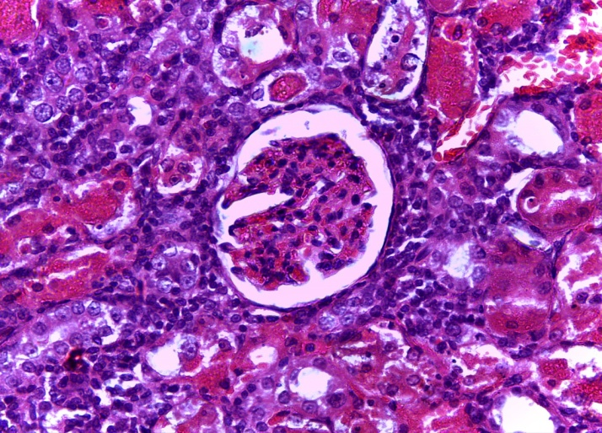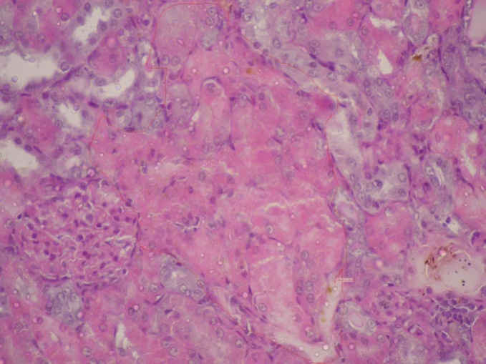

**Figure (2-b)**: Gentamycin group (G-group), its glomeruli showing congestion of afferent and efferent arterioles with interstitial tubular necreosis (HE X600)

Figure (2-a): Gentamycin group (G-group), renal tissue with massive areas of necrosis (HEX200)

Figure (3-a): Taurine - treated group (G+T group), renal tissue with mild necrosis (HEX200).

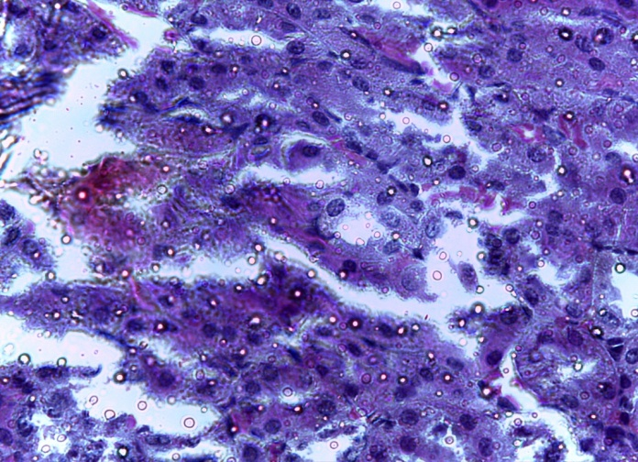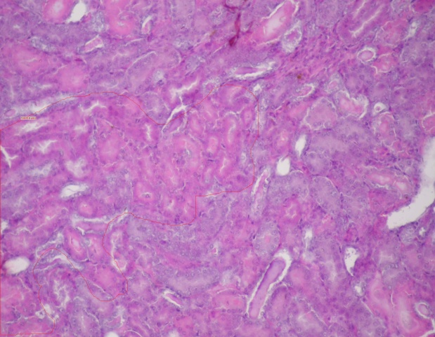

**Figure (3-b):** Taurine - treated group (G+T group): renal tubules showing mild hydropic changes and mild interstial edema (HEX600)

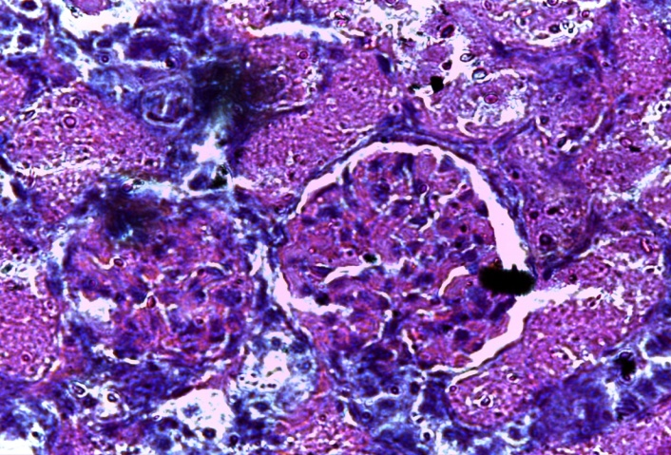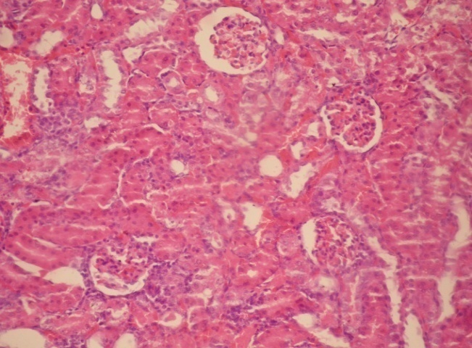

**Figure (4-b):** Calcium - treated group (G+Ca group): renal tissue showing patent arterioles, mild edema and patent renal tubules (HEX600)

Figure (4-a): Calcium - treated group (G+Ca group): Renal tissue appears nearly normal (HEX200).

**Discussion**

The ability of the kidney to filter creatinine (a non-protein waste product of creatinine phosphate metabolism) is reduced during renal dysfunction as a result of diminished glomerular filtration rate. Moreover, the elevated levels of blood urea and urea nitrogen occur during renal dysfunction **(18)**. Remarkable elevation of urea and creatinine in the animals treated only with gentamycin is an indicator of severe tubular necrosis **(1)**. The values of serum sodium and potassium were decreased in comparison with the control. The histopathological analysis showed that, rats treated with gentamycin had large areas of necrosis in proximal convoluted tubules. Souza et al., 2008 has demonstrated that administration of aminoglycosides cause intracellular edema, basal membrane interruption, glomerulus narrowing of the Bowman’s capsule and acute tubule necrosis. Further, among the various subcellular organelles potentially involved in tubular cell necrosis and apoptosis are lysosomes and mitochondria which have been shown to send death signals through the activation of specific stress sensors **(20)**. It is well known that gentamycin accumulates in the lysosomes of kidney proximal tubular cells **(21)** causing its rupture and release of acid hydrolyses which contribute to cell necrosis. **(20)**

The concurrent administration of taurine with gentamycin has revealed a significant decrease in BUN and serum creatinine than gentamycin treated rats. The histopathological examination has demonstrated insignificant decrease in areas of necrotic tissue than gentamycin treated group. That may suspect a beneficial role of taurine as a protective against gentamycin nephrotoxicity. This effect may be of limited value as BUN, creatinine and necrotic areas are significantly more than normal control rats. Taurine failed to prevent the edema caused by gentamicin administration. The protective role in gentamicin induced acute tubular necrosis by attenuating the concentration of gentamicin accumulated within the kidney tissue and by protection of subcellular organelles, such as lysosomes and mitochondria, as well as on the cytoplasmic membrane. Additionally, taurine may cause protection through various possible mechanisms as it may increase tissue osmolarity and keep water as a hydroxyl radical scavenger. It may bind free metal ions such as Fe2+ by its sulfonic acid group and form complexes; it may reduce tissue hypoxia and, possibly, induce Gluathione perioxidase (Gpx) and Superoxide dismutase SOD **(17)**. There is considerable evidence that taurine modulates many Ca2+ dependent processes, and it has been suggested to be the main mechanism for its protective effect. **(11)**  So, the role of Ca2+ in gentamycin induced nephropathy is studied.

Administration of Ca2+ carbonate orally in combination with gentamycin revealed a significant decrease in BUN and serum creatinine while significant increase in both sodium and potassium levels. Regarding areas of necrosis it is highly significant decreased than gentamycin treated animals only. These results exerted protective effect against renal dysfunction and structural damage caused by gentamycin. Comparing with control animals there is non-significant changes in all detected parameters which may suppose a highly protective effect than taurine.

**References:**

1. **Nenad Stojiljkovic, Milan Stoiljkovic, Dragan Mihailovic, Pavle Randjelovic, Sonja Ilic, Marija Gocmanac-Ignjatovic and MilicaVeljkovic**: Beneficial Effects of Calcium Oral Coadministration in Gentamicin-Induced Nephrotoxicity in Rats. Renal Failure, 2012; 34(5): 622–627.
2. **Soliman K. M., Abdul-Hamid M., Othman A. I.:** Med. Sci. Monit., 2007, 13, 73—83.

1. **Kadkhodaee M., Khastar H., Faghihi M., Ghaznavi R., Zahmatkesh M.:** Exp. Physiol., 2005, 90, 571—576.
2. **Stojiljkovic N, Stoiljkovic M, Randjelovic P, Veljkovic S, Mihailovic D**.: Cytoprotective effect of vitamin C against gentamicin-induced acute kidney injury in rats. Exp Toxicol Pathol. 2012; 64(1–2):69–74.
3. **Sener G., Sehirli A. O., Altunbas H. Z., Ersoy Y., Paskaloglu K., Arbak S., Ayanoglu-Dulger G., J.:** Pineal. Res., 2002, 32, 231—236.
4. **Parlakpinar H., Tasdemir S., Polat A., Bay-Karabulut A., Vardi N., Ucar M.:** Acet A., Toxicology,2005, 207, 169—177.
5. **Sundin DP, Sandoval R, Molitoris BA.**: Gentamicin inhibits renal protein and phospholipid metabolism in rats. J Am Soc Nephrol. 2001; 12(1):114–123.
6. **Abdel Raheem IT, Abdel Ghany AA, Mohamed GA.:** Protective effect of quercetin against gentamicin-induced nephrotoxicity in rats.Biol Pharm Bull 2009; 32: 61-7.
7. **Koyner JL, Sher AR, Murray PT**.: Antioxidants. Do they have a place in the prevention or therapy of acute kidney injury? Nephron ExpNephrol 2008; 109:e109–17.
8. **ZorovDB:** Amelioration of aminoglycoside nephrotoxicity requires protection of renalmitochondria.KidneyInt 2010; 77:841–3.
9. **Huxtable RJ:** Physiological action of taurine. Physiol Rev., 1992; 72: 101–163.
10. **Marcinkiewicz J, Kurnyta M, Biedron R, Bobek M, Kontny E, Maslinski W.:** Anti-inflammatory effects of taurine derivatives (taurine chloramine,taurine bromamine, and taurolidine) are mediated by different mechanisms. AdvExp Med Biol 2006, 583:481-492.
11. **Ogino T, than TA, Hosako M, Ozaki M, Omori M, Okada S.: Taurine** chloramine: a possible oxidant reservoir. AdvExp Med Biol, 2009, 643:451-461.
12. **Kim C and Cha YN.:** Production of reactive oxygen and nitrogen species in phagocytes is regulated by taurine chloramine. AdvExp Med Biol 2009, 643:463-472.
13. **Ali BH, Al-Qarawi AA, Mousa HM: The** effect of calcium load and the calcium channel blocker verapamil on gentamicin nephrotoxicity in rats. Food Chem Toxicol. 2002; 40(12): 1843–1847.
14. **Upaganlawar A, Mamta F,Shivkumar R, Balaraman R:** Modification of biochemical parameters of gentamicin nephrotoxicity by coenzymeQ10 and green tea in rats. Indian J Exp Biol 2006; 44: 416-418.

1. [**Ayşen Erdem**](http://ndt.oxfordjournals.org/search?author1=Ay%C5%9Fen+Erdem&sortspec=date&submit=Submit)**,**[**Nimet Ünay Gündogan**](http://ndt.oxfordjournals.org/search?author1=Nimet+%C3%9Cnay+G%C3%BCndogan&sortspec=date&submit=Submit)**,**[**Alp Usubütün**](http://ndt.oxfordjournals.org/search?author1=Alp+Usub%C3%BCt%C3%BCn&sortspec=date&submit=Submit)[**Kamer Kılınç**](http://ndt.oxfordjournals.org/search?author1=Kamer+K%C4%B1l%C4%B1n%C3%A7&sortspec=date&submit=Submit)**,**[**Ş. Remzi Erdem**](http://ndt.oxfordjournals.org/search?author1=%C5%9E.+Remzi+Erdem&sortspec=date&submit=Submit)**,**[**Aysun Kara**](http://ndt.oxfordjournals.org/search?author1=Aysun+Kara&sortspec=date&submit=Submit)**and Atilla Bozkurt :** The protective effect of taurine against gentamicin induced acute tubular necrosis in rats. Nephrol. Dial. Transplant. 2000, 15 (8): 1175-1182. doi: 10.1093/ndt/15.8.1175.
2. **V. CHINNAPA REDDY, V. AMULYA, CH. ANUSHA LAKSHMI, D. BALA PRAVEEN KUMAR REDDY, D. PRATIMA, A.  
   THANGA THIRUPATHI , K. PAVAN KUMAR, S. SENGOTTUVELU:** EFFECT OF SIMVASTATIN IN GENTAMICIN INDUCED NEPHROTOXICITY IN ALBINO RATS, Academic Sciences Asian Journal of Pharmaceutical and Clinical Research Vol. 5, Issue 1, 2012 , ISSN - 0974-2441.
3. **Lakshmi BVS, Sudhakar M:** Protective effect of zingiber officinale on gentamicin-induced nephrotoxicity in rats. Int J, Pharmacol. 2010; 6(1):58–62.
4. **Servais H, Jossin Y, Van Bambeke F, Tulkens PM, Mingeot- Leclercq MP**: Gentamicin causes apoptosis at low concentrations in renal LLC-PK1 cells subjected to electroporation. Antimicrob Agents Chemother. 2006; 50(4):1213–1221.
5. **Stojiljkovic N, Mihailovic D, Veljkovic S, Stoiljkovic M, Jovanovic I:** Glomerular basement membrane alterations induced by gentamicin administration in rats. Exp Toxicol Pathol. 2008; 60(1):69–75.

*corresponding auther: Eslam S. Metwally

department of Forensic and toxicology, Faculty of medicine, Benha university

Tel.01129276210

E. mail: eslamsamy2020@yahoo.com